Algorithms assignment 1 semester 2

Q1.
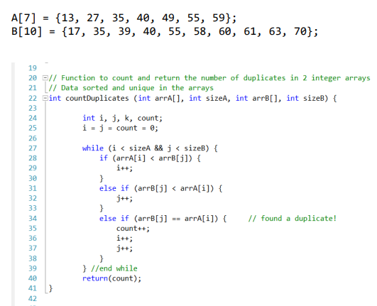
- Timesteps of function: *we always calculate worst case scenario as it guarantees the algorithm will never take longer than that.

Size A = N Size B = M use N or M without loss of generality
Line | Cost | numTimes | Cost*numTimes | Total
24 & 25 | 1 for each | 1 for each | 2
27 | 1 | 2N+1 | 2N+1
28 | 1 | 2N | 2N
29 | 1 | N | N
31 & 32 | 1 for each | N | 2N
40 | 1 | 1 | 1
 |  |  |  | F(n)=7N+4

(b)
Big O notation = 0(n) (linear search)
Time complexity: the run time complexity grows directly in proportion to n. Time complexity refers to the number of times a statement executes and we can prove this by using the time command
Generally
- Don’t count I/0 steps
- It gives a good approximation of the actual run time
- It is a good way to compare algorithms

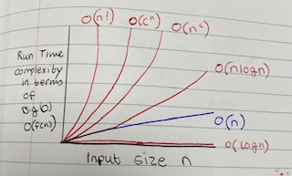
o(n) is a fair time complexity with respect to the others

Q2.
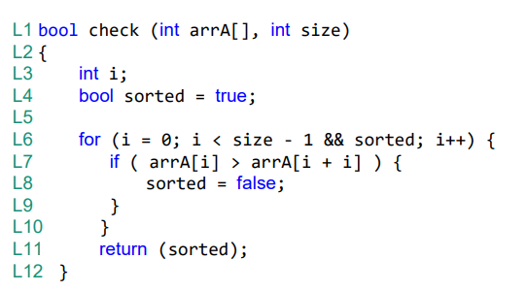

Best case scenario: the best case for which our algorithm the minimum number of operations. It gives us a lower bound of the running time and guarantees that the algorithm will never take less time than that. In this program the best case is that the program is not sorted in ascending order therefore the program will only run once as the for loop only checks if the number in position i is greater the number in position i + 1. If arrA[i] is greater than arrA[i + 1] eg {5,2,4,5} sorted=false and the program will stop running.
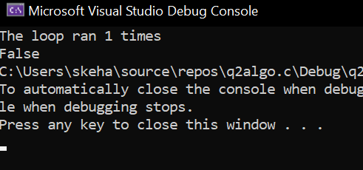
Array size 4: When sorted = false the loop ran once…. Best case
Worst case scenario: is an input for which our algorithm executes the maximum number of operations. It provides an upper bound of the running time and guarantees that the algorithm will never take time longer than that. In the worst case this program would be sorted. If If arrA[i] is less than than arra[i + 1] eg {2,3,4,5} sorted= true, the program will return(sorted) and run through the program again getting the same output for the array size.
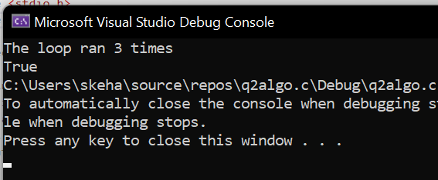
Array size 4: When sorted = true the program runs 3 times….. worst case

Q3.
(a)
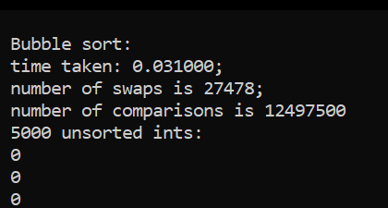
- Selection sort was has the fastest time complexity as it has a minimum amount of swaps and the min amount of comparisons.
- Bubble sort has a high amount of comparisons this is good for accuracy but with more time to execute

- insertion sort compares and swaps the most integers although bubble sort takes the longer to execute. This seems like the most efficient sorting method as it compares the most but doesn’t take the longest
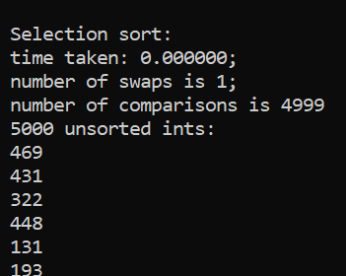
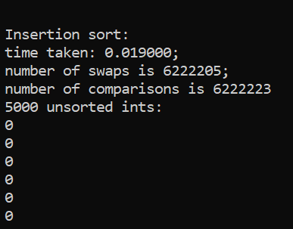

(b)
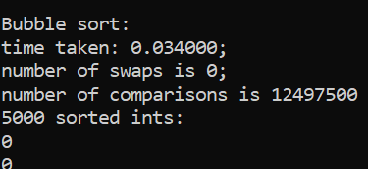
- bubble sort takes the longest to execute as it has the most amount of comparisons this allows for accurate results
- Selection sort and insertion sort take the same minimal amount of time to execute, they both have the minimum number of comparisons. This allows for quick execution

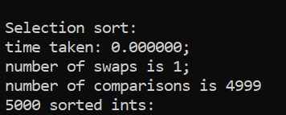
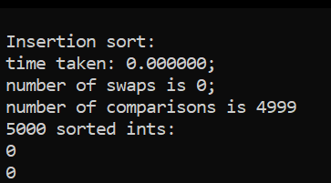

Bubble sort: this sorting method has a high comparison rate but is the slowest of the sorting methods. It works by repeatedly swapping the adjacent elements if they are in the wrong order. That’s why there are no swaps in part b and a lot in part a.
Selection sort: this sorting method is an efficient sorting algorithm based on comparison operations. It adds one element in each iteration. It selects the smallest element in the array and moves it to the beginning of the array swapping it with the largest, that why we see 1 swap.
Insertion sort: sorts an array in ascending order. It compares the current element to the element + 1 and swaps when the element is smaller than its predecessor, it compares to the element before. It moves the greater element one position up to make space for the swapped element. In the unsorted array there are loads of swaps because it is constantly moving ints whereas the are none in part b as the sorting is already complete.

Plagiarism Declaration: “I am aware of what plagiarism is and include this here to confirm that this work is my own”

